
QUALITY ALERT

Customer: Seaway Date: March 24, 2024
Die: 15768 Colour: All
Type of Complaint: Customer COMPLAINED

Q.A # Q.I.R # CUSTOMER NCR #

Description: Customer COMPLAINED the hung channel is small causing the shoe not slide smoothly.
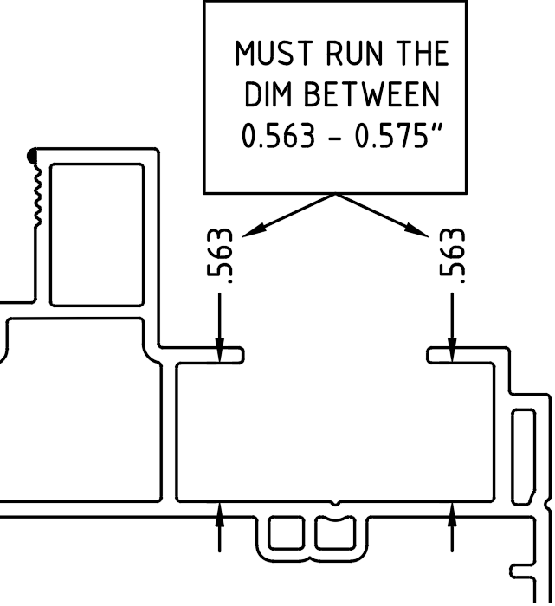

PLEASE MAKE SURE THE DIMENSION IN TOLERANCE

BY SIGNING BELOW, YOU ACKNOWLEDGE THE PROBLEM ABOVE AND AGREE TO MONITOR THIS ISSUE IN FUTURE PRODUCTION RUNS.
DAY SHIFT |  | AFTERNOON SHIFT |  | NIGHT SHIFT
NAME | SIGNATURE | NAME | SIGNATURE | NAME | SIGNATURE

